

Congratulations on downloading the ***Sports Administrator***. It’s easy to use and I am confident that it will make running your sports carnivals much smoother.

Just a few things to know before you install the program.

1. The ***Sports Administrator*** is designed to run under Windows 7 and above.
2. When you first run the ***Sports Administrator*** the ‘*Maintain Carnivals***’** form will be displayed. From this form you can add a new carnival, look at the demo carnival or copy the demo carnival that is included with the program.   
   To create a new carnival push the ‘*New Carnival’* button. Enter a descriptive name for the new carnival and then push the Locate button to enter a file name for the carnival (every carnival needs both a filename and a descriptive name). Push OK and the carnival will be created.  
   Once a carnival is listed as ‘Available’ in the list you can double-click on it to make it active and work on it.
3. There are step-by-step instructions in the ‘*Setup Carnival’* form (accessed from the Main Menu) that will help guide you through the setup process. This form does not need to be used to setup a carnival. All the functions available in the *‘Setup Carnival’* form are available from the Main Menu.

I hope the ***Sports Administrator*** meets your expectations. Please contact me if you are having any difficulties or have any suggestions. I look forward to hearing from you soon.



### Installation

**To install the *Sports Administrator*:**

1. Download the latest release [ZIP file](https://github.com/ruddj/SportsAdmin/releases/latest) and extract to a folder users have modify access to.
2. If you wish to use Sports Administrator across a network, you need to have the application run from each computer.   
   While the Carnival data can be shared on an network drive the main application needs to have a different copy for each user.

**Note:**

Because MS Access database files are used to store the carnival results, you are able to access those files through MS Access or through a number of other applications including MS Word and MS Excel. This means that you could generate your own reports and graphs. Feel free to access the results in this manner but DO NOT modify the data. This could compromise the integrity of the database.

A number of web template files and documents are stored in sub-folders under the installation directory. Feel free to use and modify these documents.

### *Sports Administrator* Quick Start Guide

Thanks for choosing the *Sports Administrator* to manage your carnivals. Here is a brief quick start guide to get your carnival underway.

1. Have a good look at the demo carnivals. Play with these a bit to familiarise yourself with the programme. Don’t be too concerned about modifying it. You can always reinstall the demo files later.
2. On the main menu push the *Setup Carnival* button.
3. Follow the steps one through eight to set up your carnival from scratch.
4. Firstly create a new carnival. Give it a name and specify a file for the carnival to be stored in.
5. Setup the necessary point scales. Usually there are different point scales for different events. For example grand finals usually receive more points then heats.
6. Add the appropriate teams that will be competing in the carnival.
7. Add the events that will be held during the carnival. It is a good idea to set up one event first making sure that is correct and then copy it to create the other events.
8. Allocate default lanes to each team if you haven’t done so already. The *Sports Administrator* will automatically put competitors into these lanes when they are enrolled in an event.
9. Set the event order. This is optional and is not usually necessary for carnivals where marshalling lists aren’t used
10. If you are responsible for entering the competitors into the events push the enter competitors button. (The *Sports Administrator* also allows you to generate disks with all the events on for each team. A person for each team can then enter the competitors’ names into the events for you. This feature is usually only used for inter-school carnivals or the like).  
    There are two ways of getting competitors into your carnival.   
    a) The easiest way is to import all competitor details from a text file that can be generated by, say, a school administration system. The required format can be found in the help file. Push the *Import Carnival Competitors from a Text File* button.  
    b) Alternatively you can enter each competitor manually. Push the *Enter Carnival Competitors Manually* button.  
      
    Lastly you must enrol competitors into events. Push the *Enter Competitors into Events* button, select the event to enter competitors into and start adding competitors to it.
11. The last thing to do is to generate event lists. Again this may not be necessary if you do not require marshalling sheets.  
      
    Your carnival is now ready. When competitor results start coming in push the *Enter Results* button on the Main Menu to begin entering them.

### Getting Started

The *Sports Administrator* installation program creates a program group with (1) a *Sports Administrator* program icon, (2) a Help icon and (3) an uninstall icon. Double click the *Sports Administrator* program icon to launch the program.

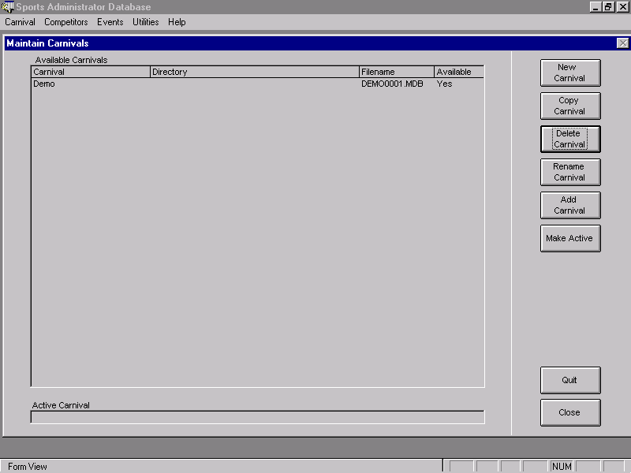

When you run the program for the first time, you are presented with the *Maintain Carnivals* dialog. Three sample carnivals for Primary Athletics and Swimming and Secondary Athletics will be displayed in the list of carnivals. You will see that the carnival has a description, directory, filename and an available flag (a carnival is available if the file in the given location exists).

**To look at a *demo* carnival** select it by clicking on it and pushing the *Make Active* button on the right hand side. The *Sports Administrator* will load the carnival and then inform you that it is ready to be used. Push the OK button and you will be presented with the Main Menu.

#### Creating a carnival

**Creating a new carnival** is just as simple. First, push the *New Carnival* button. A dialog will be displayed asking for a carnival description and for a filename (each carnival is stored in its own file). Enter a name that describes the carnival you want to create (e.g. *1999 Secondary Athletics Carnival*). To enter a filename push the *Locate* button. You will be presented with an *Open File* dialog. Find the directory where you want to put the carnival file and then type in a filename that describes the carnival (e.g. *99sec-at).* Push the OK button (in the locate file dialog) and then push the OK button again (in the New Carnival dialog). After a few seconds the *Sports Administrator* will create a new file with the name and location you specified and will display it in the list of carnivals on the left of the screen. To start using the new carnival click on it and push the *Make Active* button.

You are now presented with the *Sports Administrator* Main Menu. It is from this screen that you access all the *Sports Administrator's* features. You can also use the menu bar at the top of the screen.

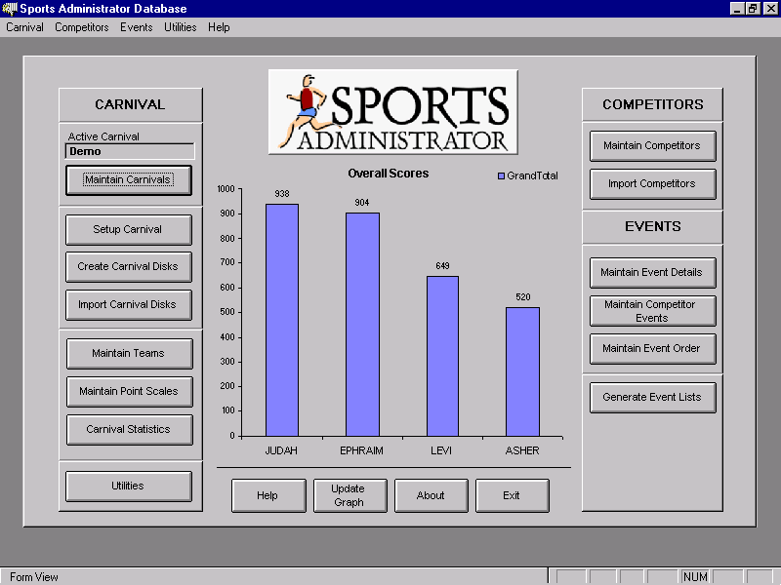

**Setting up a carnival** from scratch is also a simple process. Once you are familiar with the program you should be able to set up a carnival from scratch in less than 15 minutes. One advantage of the *Sports Administrator* is that once you have set up a carnival you simple copy it for subsequent years … you never have to set it up again.

#### Setting Up Teams

**Setting up Teams** is done by pushing the *Maintain Teams* button. You are presented with an empty *Maintain Team*s dialog. To add a new team push the *Add Team* button. The new dialog allows you to enter a Code for the team (Mansfield State High could be shortened to MSH), the full name of the team, and the number of competitors in the team (this is only required if you need to calculate percentile scores). The bottom of the dialog show what extra points have been allocated to the team. This option might be used to allocate points for the quality of team "war-cry" etc.

Lastly you can allocate default lanes for team competitors. Often a team will run in set lanes (team 1 may be allocated lanes 1 and 5, team 2 may be allocated lanes 2 and 6 and so on). To do this push the *Allocate Default Lanes* button. You are presented with a dialog that allows you to set the default lanes for all teams. For each lane select the team who should be allocated this lane by default. This feature is used when adding competitors to events. When you add a competitor to an event the *Sports Administrator* will look to see if there is a default lane for that team and then place the competitor in the appropriate lane. (Note that this can be done manually).

Push the OK button (on the *Allocate Lanes* dialog) and the OK button (on the *Add Team* dialog). Continue to add the required teams. When you are finished push the Close button.

#### Point Scales

**Setting up Point Scales** is done before setting up any events. Most carnivals allocate more points to grand final events than they do to heats. Often relays attract more points than an individual heat. To do this determine what points will be allocated to which events and then create a point scale for each.

Push the *Maintain Point Scales* button. The dialog displayed allows you to add, delete and modify point scales. Push the *Add Point Scale* button. Enter an appropriate description (say *Heats*). The *Heats* points scale will appear in the list on the left. Select it by clicking on it.

It is now necessary to enter a place and a point for each place that may be obtained in an event using this point scale. If this point scale will be used for an 800m heat in which there may be up to 20 competitors then we must enter points for each place from 1 through to 20. It is always better to have more entries here than we need. You will notice on the bottom left of the dialog an option to automatically create entries for places and points. This is very useful when you want to allocate a single point for all competitors no matter what place they come. Simply put in the number of places you wish to create and the point you wish to associate with those places and push the *Create* button. You will see them appear in the list. Now you can go through and change them manually if needed.

Create all the point scales you need. Normally only a few are required. One for heats, relays and finals is usually sufficient. Push the *Close* button when you are ready.

#### Create Events

We are now ready to **create the events**. Push the *Maintain Events Types* button on the main menu. An empty Maintain Events Types dialog appears. It is important to understand the terms used in this part of the *Sports Administrator*.

An *Event Type* refers to a type of event (say the 100m Sprint, High Jump, 4x100m Relay etc.)

An *Event* refers to an Age/Gender specific event (say the 14yr Girls High Jump).

A *Heat* refers to a particular heat within that Age/Gender event, whether it be a final or heat (e.g. Heat 1-14yr Girls-100m Sprint or Grand Final-14yr Girls-100m Sprint.

Each *Event Type* is made up of a number of *Events* which is made up of a number of *Heats.* Because *Heats* can refer to both heats and finals we need some way of distinguishing between them.

This is where *Final Levels* come in to it. Each *Heat* is assigned a *Final Level*. Every *Event* has at least one *Heat* with a *Final Level* of 0 (zero). This is usually the Grand Final. You can think of a *Final Level* of 0 as being a grand final, a *Final Level* of 1 as being a semi-final, a *Final Level* of 2 as being a quarter-final and so on. If in your carnival you simple have heats and then a final then the heats would be *Final Level 1* and your final would be *Final Level 0.* If you do not run any heats and simple have a number of finals then all your heats would be set at *Final Level 0.*

I know this sounds a bit confusing and you now wish you bought some other sports program but don't give up … it is not as difficult as it might seem once you get into it … and it is very powerful! Let's create an event now.

Push the *Add Event* button. A small dialog appears that allows you type in the name of the new event. Enter the name (e.g. 100m Sprint, 50m Freestyle, High Jump, Discus etc). Push the *OK* button.

A relatively empty *Maintain Event Type* form appears with the name of the new event entered in. On the left hand side you have an empty list of *Events* and on the right hand side you have an empty list of *Heats.* Firstly we want to enter the *Events.*

Locate the cursor in “Age” field. Enter an age for the event. If the event is for a single age only (say 14 years) then simply enter the age (14). If the event is for all ages *under* and including a certain age (say 13 years and under) enter the age with "_U" added to it (13_U). If the event is for all ages *over* and including a certain age (say 17 years and over) enter the age with "_O" added to it (17_O). Now select the gender of the event from the drop down list in the first empty spot in the *Events* list. If you wish to enter a record for this event then double click on the empty record field. A records dialog appears in which you can enter the record details. Add the remaining events in this manner.

There are two ways of **setting up the heats** within an event. You can manually add each heat by selecting the *Event* (click in either the age or gender fields of the event you want to set up) and adding the heat in the *heats* list. However this can take a long time! Alternatively you can use the automatic creation of heats by pushing the *Setup Heats* button.

After pushing the *Setup Heats* button a small form is displayed allowing you to enter (1) the *Final Level* (2) the number of heats in the *Final Level* (3) the *Point Scale* allocated to the *Final Level* (4) the *Promotion Method* of the *Final Level*, (5) whether Results (time/distance etc) or Place should be used to promote the *Final Level, and lastly (6) the number of competitors in the heat*. An example or two may be useful.

***Example 1***: Say we are working on the 100m Sprint. Each *Event* is comprised of at most 6 heats from which the top 8 competitors heat in a single grand final. We would enter the following:

|  |  |  |  |  |  |
| --- | --- | --- | --- | --- | --- |
| Final Level | # of Heats | Point Scale | Promotion Method | Use Results (X) / Places () | # of Comp in Heat |
| 0 | 1 | FINALS | NONE | X |  |
| 1 | 6 | HEATS | SMOOTH | X |  |

As always, the first Final Level is 0 (grand-final) and our second Final Level is 1 (for the heats). There is only a single grand-final heat so the “# of Heats” for Final Level 0 is set to 1. However there a 6 heats so “# of Heats” for Final Level 1 is set to 6. Obviously the Point Scale options are determined by what you set up before. In this instance the promotion method doesn't matter seeing we are promoting into a single event only so we could choose either Smooth or Staggered. Lastly, we will use results to do the promoting (which is almost always the case) seeing that we are interested in the 8 fastest rather than the 8 who came first and second but may not have gained the best times. (Consult the on-line help for more detailed information about how this aspect of the program works).

***Example 2***: Say we are working on the 100m Sprint. Each *Event* is comprised of only 8 'heats' with NO grand final (this is often the case when there is insufficient time to run a grand-final). We would enter the following:

|  |  |  |  |  |  |
| --- | --- | --- | --- | --- | --- |
| Final Level | # of Heats | Point Scale | Promotion Method | Use Results (X) / Places () | # of Comp in Heat |
| 0 | 8 | FINALS | NONE | X |  |

As always, the first Final Level is 0. There are 8 heats so the “# of Heats” for Final Level 0 is set to 8. Again the Point Scale options are determined by what you set up before. In this instance the promotion method is set to “None” since we are not promoting into any event (there are no grand finals as such). Lastly, the results field can be set at either “Results” or “Places” since we are not promoting any events.

***Example 3***: Say we are working on the 50m Freestyle event at a large carnival. The pool has 10 lanes and there are 100 competitors competing. The *first 3* (ie those placed first, second or third) in each heat go into the semi-finals and then the *fastest 10* go into the grand-final. We would enter the following:

|  |  |  |  |  |  |
| --- | --- | --- | --- | --- | --- |
| Final Level | # of Heats | Point Scale | Promotion Method | Use Results (X) / Places () | # of Comp in Heat |
| 0 | 1 | FINALS | NONE |  |  |
| 1 | 3 | HEATS | SMOOTH | X (Results) |  |
| 2 | 10 | HEATS | SMOOTH |  (Places) |  |

Once you have set up the finals the way you want them push the “Create Heats and Finals” button. In a few seconds all the heats and finals will be created for each *Event* you created earlier.

The last thing to do on this form is to specify the ***Lane Promotion***. Push the Lane Promotion button to enter the place and lane into which a competitor will be placed when promoted into the next final level.

Create the rest of the Event Types by either copying the event that you just created or setting it up from scratch.

#### Maintain Event Order

From the main menu push the *Maintain Event Order* button. You are presented with a form in which you can enter the event numbers for each event. It is not necessary to give an event a number. Numbers are used only to make carnival day a little easier.

The top right of the form allows you to order the events in any way you choose. This makes it easier to enter the event numbers.

By turning on the *auto-renumber* feature you can easily insert numbers anywhere in the event order.

Lastly the *Slide Event Numbers Up* button will remove any gaps that there might be in the numbering order.

#### Importing Competitor Data

The *Sports Administrator* allows you to import competitors from a text file. A simple text needs to be generated in the following format:

Given Name, Surname, House/School Code, Sex, Age, DOB, PIN

All fields are required except the last three. Only one of the Age / DOB fields is required. If a DOB is supplied the *Sports Administrator* will calculate the age. Alternatively if an age is supplied the program will set the competitor’s DOB to the first day of the year in which he was born. PIN is optional but can be useful to link students to their student number.

To import competitors into the database first generate a plain text file in the format described above. Enter the location of that file or locate it by pushing the *Locate* button. If there is already data in the temporary table clear it by pushing the *Clear Temporary Data* file. Now push the *View Text File* button. The data in the text file will be imported into a temporary location and displayed in the grid on the form. Once the text file has been displayed you can check its accuracy. If you are happy with it simply push the *Import Competitors* button and the data will be imported into the current carnival.

#### Enter Results

Once the events are set up you can begin to enter competitors into events. Some consideration should be given to this so as to determine what will work best for your carnival. If it is necessary to generate marshalling lists *prior* to the carnival then it will be desirable to enter all competitors into heats before the carnival begins. However it is often more convenient to simply enter the competitors and the results as they events are completed.

To begin entering competitors into events or to enter results against a competitor push the *Enter Results* button. A form showing a number of filter options on the left hand side is displayed along with the events matching the filter on the right hand side. Once the appropriate events are displayed you can edit them by either double-clicking on it or by selecting it and pushing the *Edit Selected Heat* button.

Another form is displayed showing the event details at the top of the form and a list into which competitors can be entered at the bottom of the form. The lane, name, place and result for each competitor can be entered by clicking in the list and typing (or selecting from the list) the appropriate information. It will be useful to note the following:

1. There is no need to use a mouse at all in the section. You can move between fields and records by using the *Tab* key or the *Shift+Tab* key. The drop-down list can be displayed by moving to that field and pushing *Alt+Down-arrow* keys together.
2. If a competitor is not displayed it may be due to age restrictions applied by the event. Make sure the competitor is the correct age. If necessary, you can push the *Select from all Names* checkbox to display all competitors in the carnival.
3. The heat is automatically flagged as *Complete* when there is a result against each competitor’s name irrespective of the number of competitors in the event.
4. Places will be automatically generated if results are entered.
5. As in all forms such as this one, records can be deleted by clicking on the record selector and pushing the delete key.

#### Generate Event Lists

Once you have set up your events and have the competitors enrolled in them you can generate the event or marshalling lists. Push the *Generate Event Lists* button on the Main Menu. Select the events you are interested in on the left-hand side. Specify the age and other details in order to filter out the events that you do not want. You can double-click on any of the fields to enter an ‘*’ which acts as a wildcard. Then push the *Generate Events List* button.

Depending upon which events you chose to generate lists for, a number of reports will be generated. For example, a separate report will be generated for limited lane events, unlimited lane events, three attempts events, in the high jump events. Each of these events categories has a different report style so they are printed in separate reports.